The following manual shows how to deploy the database, the service and the Web Application step by step.

Deploy Steps

* Execute the SQL script “01_Objects_Creation.sql” located in $:/Scripts/
* Open solution “NonFraud.sln” located in $:/Source/NonFraud/
* Build the solution

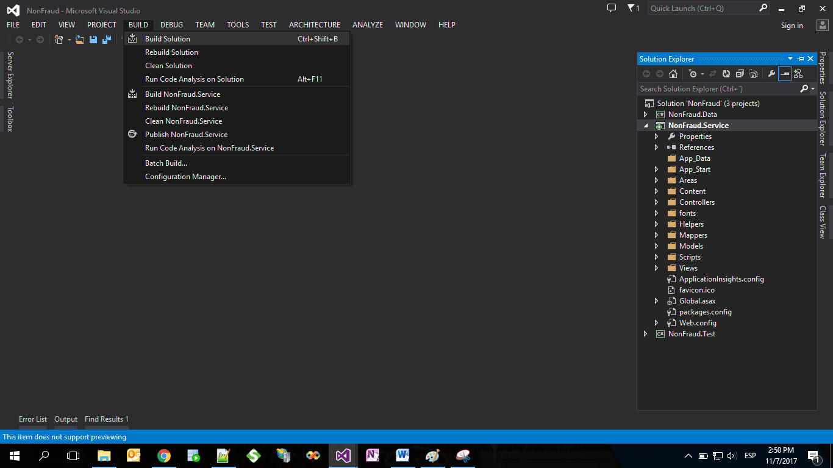

* Publish the Service project.

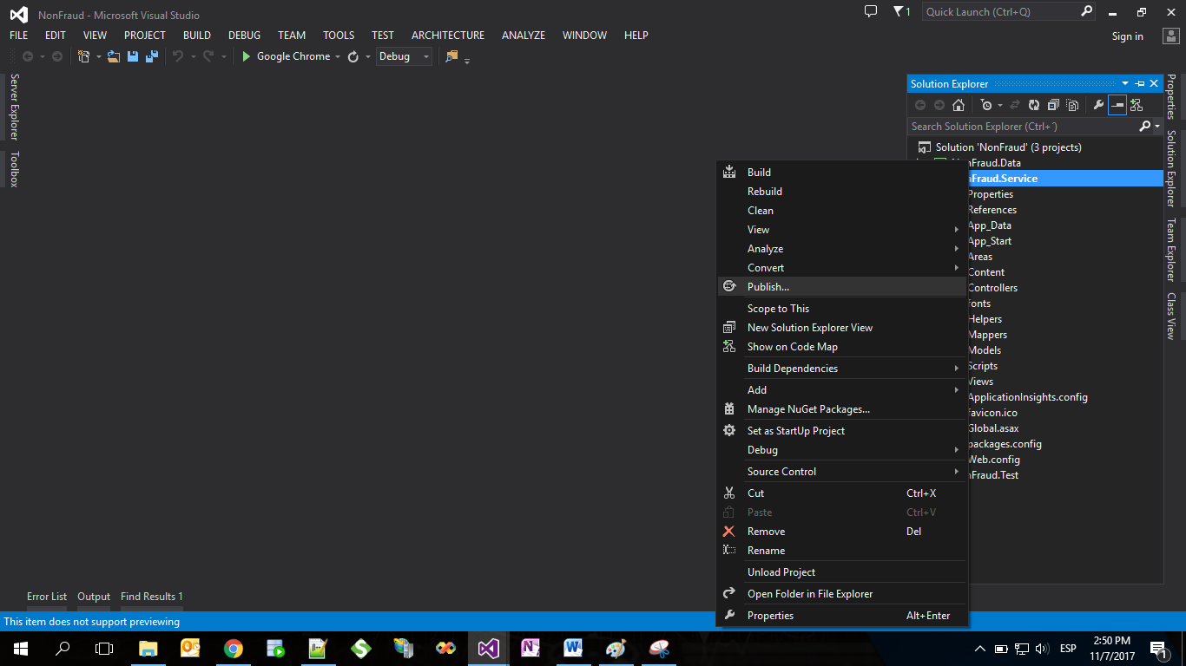

* Create a new publish profile

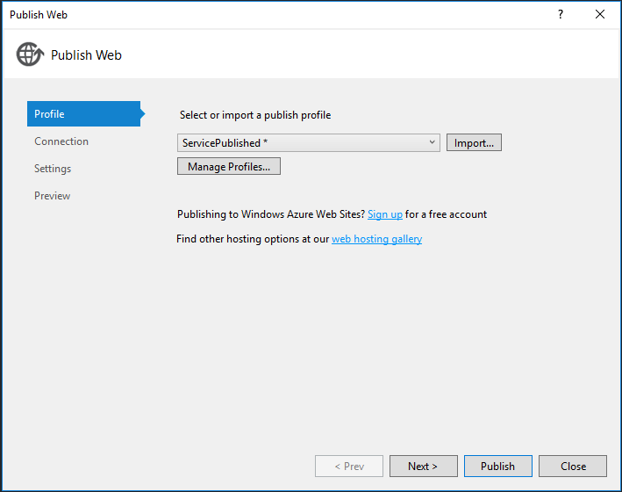

* In Connection part set “File System” in Publish Method and “C:\inetpub\wwwroot\NonFraud.Service” in Target location (folder previously created)

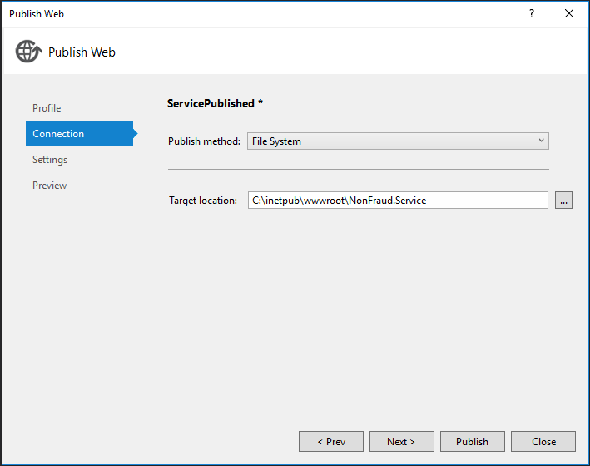

* Settings part:

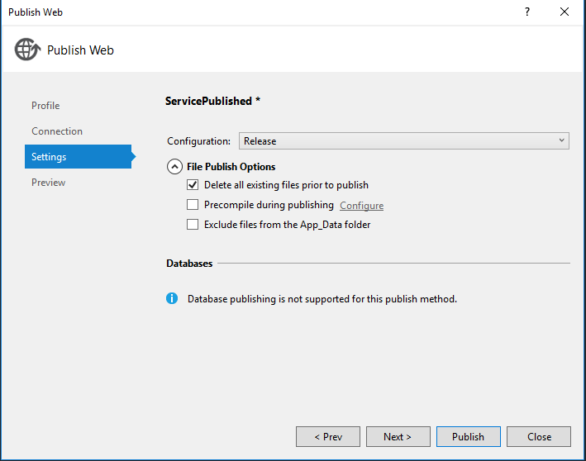

* And then publish the site.

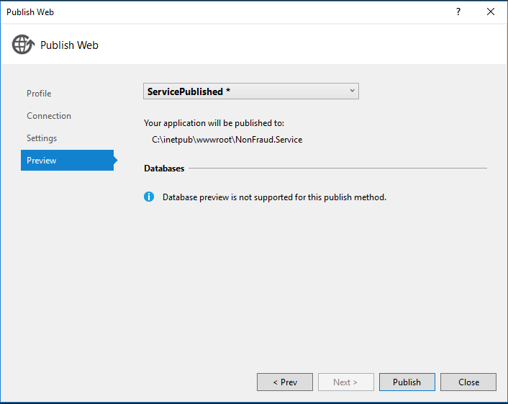

* Open Local IIS
* Go to Sites -> Add new site

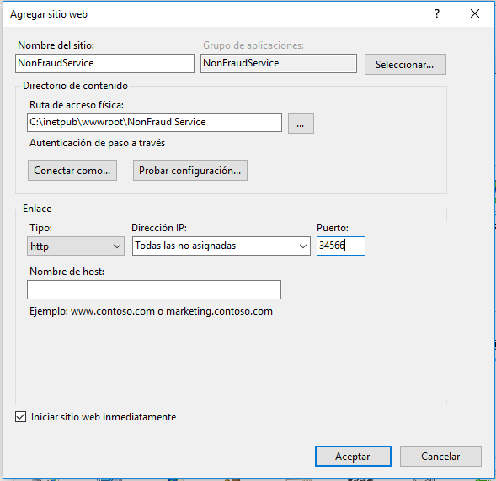

NOTE: Ensure that the port of the new website will be 34566, because it’s added in Web.config of the Web project for consume it.

* After that, the site should be working well.

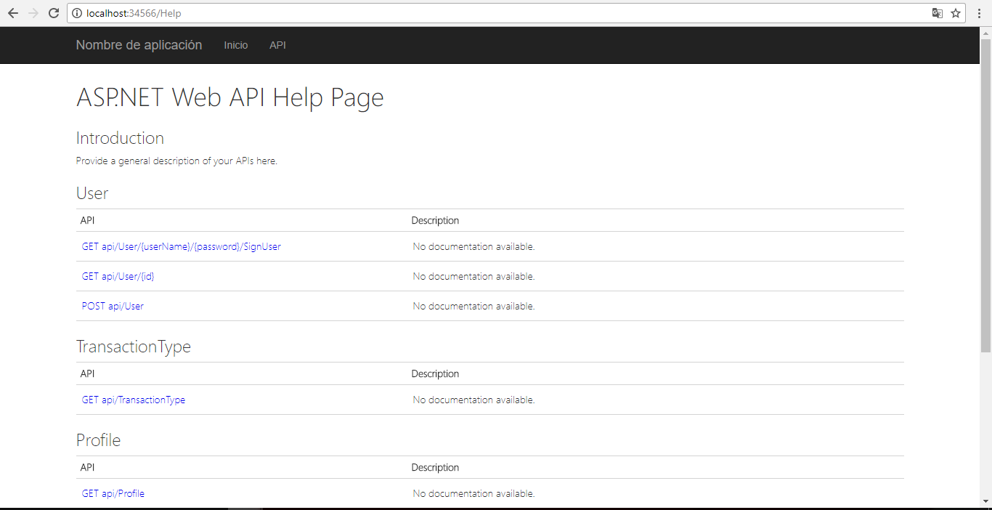

* Check in the Web.config of the published site the ConnectionString for the database previously created.

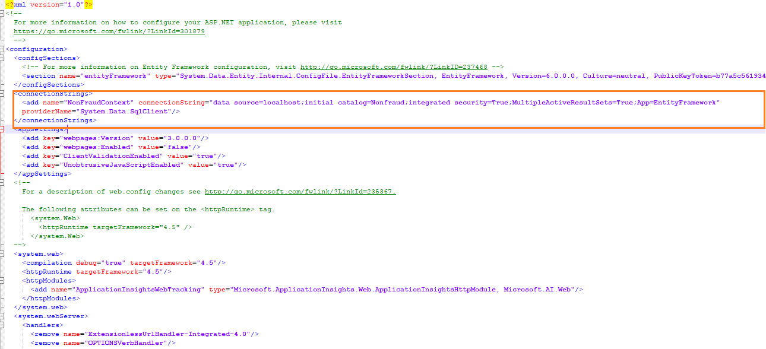

* Open “NonFraud.Web.sln” located in $:/Source/NonFraud.Web/
* Build the solution
* Publish the site (same steps as the service)

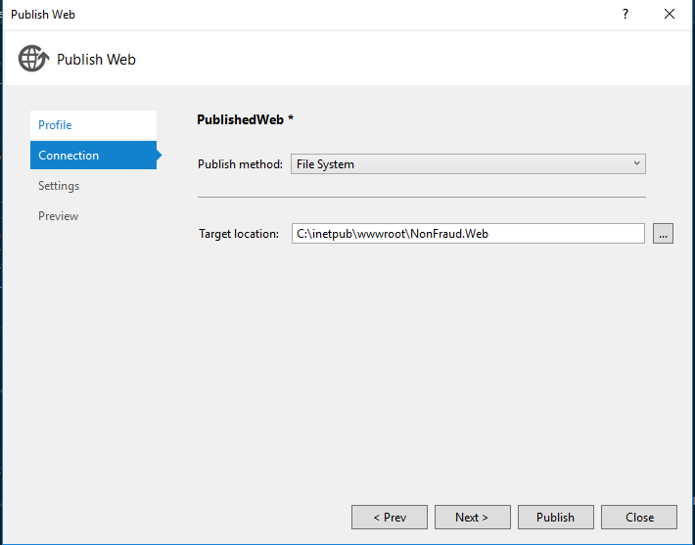

* Open Local IIS and create the application(same steps as the service)

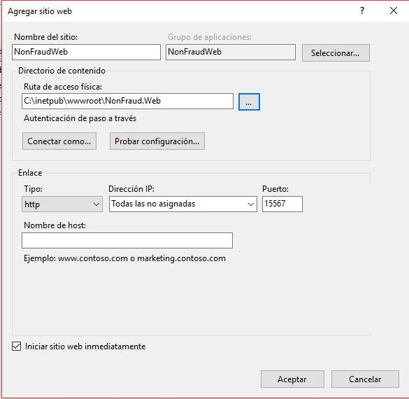

* After that, the site should be working well.

